CAMARADES Reproducibility Challenge
Title: Replication attempt of “The antidepressant impact of minocycline in rodents: A systematic review and meta-analysis” by Reis et al. (2019)
Author(s): Matheus Gallas-Lopes, Daniela Varisco Müller, Bruno Dutra Arbo, Angelo Piato, Ana Paula Herrmann
Institution(s): Departamento de Farmacologia, Universidade Federal do Rio Grande do Sul (UFRGS), Brazil; Brazilian Reproducibility Initiative in Preclinical Systematic Review and Meta-Analysis (BRISA)
Introduction / Aim
Minocycline, a second-generation tetracycline antibiotic, has been studied for its potential to alleviate depressive-like behaviors in rodent models. These behaviors are commonly measured through tests such as the Forced Swim Test (FST), Tail Suspension Test (TST), and Sucrose Preference Test (SPT), all of which are standard behavioral assays for assessing phenotypes related to symptoms of depression in humans, like despair and anhedonia.
In the systematic review and meta-analysis by Reis et al. (2019)¹, the authors investigated the effects of minocycline on both "healthy" animals, which had not undergone any experimental manipulation, and "diseased" animals, which had been subjected to interventions such as chronic stress or induced illness that disrupted normal behavior. The aim was to determine whether minocycline is able to restore “normal” behaviors or reduce depressive-like symptoms according to the available preclinical studies.
Our goal in this reproducibility challenge was to closely replicate the methodology of the original study and assess the replicability of its various components. Specifically, we aimed to replicate the comprehensive literature search, the screening for study eligibility, the extraction of study characteristics and outcome data, the assessment of risk of bias, and the meta-analyses summarizing the findings.
Methods
No attempt was made to contact the authors of the original study. Our decision was based on the principle that a well-documented and transparent report should be sufficient to allow replication without the need for additional clarification from the original authors. This approach underscores the idea that science should remain accessible and reproducible, even in the absence of the individuals who originally conducted the research, ensuring its continuity regardless of unforeseen circumstances.
The first version of the protocol for conducting our replication was registered² in Open Science Framework (OSF) prior to screening and data collection (osf.io/rq9hp). The protocol can be accessed at osf.io/59nru. During the course of our replication attempt, necessary amendments were made to the protocol, which can be found at osf.io/e8y4z.
Searches were conducted in two bibliographic databases: PubMed and Web of Science. The search strategy was designed to include broad terms describing the intervention (minocycline), terms related to depression and depressive-like behavior (outcome), and the target population (rodents). The complete search query for each database can be found in the Appendix. Although we initially planned to include PsycINFO to follow the original report, institutional access was unavailable. Despite multiple attempts to purchase access, we were unable to finalize the transaction and ultimately decided to exclude PsycINFO from our search. There were no language restrictions. The search was limited to studies published up to 2018, to match the time frame of the original study. Studies published online after September 30th, 2017 were manually excluded. The bibliographic data were imported into Rayyan software³, where duplicates were detected and removed by one of the investigators.
The screening process was conducted in two phases by two independent reviewers per record. First, a title and abstract screening was performed to identify potentially relevant studies. In the second phase, the full-text screening was carried out to evaluate eligibility based on predefined inclusion and exclusion criteria. Any discrepancies between the reviewers were resolved through discussion. The guide followed by the reviewers is available at osf.io/f95rw, and all Rayyan files with the decisions are accessible in the study repository in OSF (osf.io/q7uyf/). Specific criteria for the inclusion or exclusion of records can be found in the study protocol.
Data extraction was performed by two independent reviewers, with discrepancies resolved by a third reviewer when necessary. Key study characteristics, such as species, depression model, minocycline dose, and outcome measures were extracted. Full details of the extracted characteristics are available in the protocol. Reviewers followed a guide for data extraction, which can be accessed at osf.io/j9hrw. All data, including risk of bias, were extracted using a Jotform® online form. An example of a completed form is available at osf.io/hmkbe. The raw data from both qualitative and quantitative extractions by both reviewers are available at osf.io/nt8f9.
The risk of bias was assessed independently by two reviewers, with discrepancies discussed and resolved between them. A guide for evaluating risk of bias is available at osf.io/j9hrw. The raw data from both reviewers' assessments are accessible at osf.io/gp4t5. The assessment followed all the topics outlined in the SYRCLE Risk of Bias Tool⁴. For item 10, "Other: Was the study apparently free of other problems that could result in a high risk of bias?", we specifically evaluated whether the intervention was applied independently to each experimental unit, ensuring that experimental units could not influence each other. Additionally, we checked if both the control and experimental groups underwent procedures and experienced conditions that were intentionally designed to be comparable. The original report did not specify what was considered when judging this item.
The effect size was calculated using the standardized mean difference (SMD) using Hedges' g method. Following Reis et al. (2019), multiple measures from the same treatment group were treated as independent SMDs but analyzed using robust variance estimation (RVE) to account for dependency. Heterogeneity was assessed using I², τ², and Cochran's Q statistics (the original study only reported I², though). Sensitivity analyses were performed using the leave-one-out method and by excluding studies with at least one high risk score. For studies with multiple treatment groups, SMDs were calculated from combined group data⁵. If only the standard error of the mean (SEM) was provided, it was converted to standard deviation (SD). Only the final time point from longitudinal studies was used. Effect sizes were “flipped” when needed to adjust the direction of the effect for specific behavioural outcomes in order to properly interpret the effects of minocycline and ensure consistency (this was not mentioned in the original report). Publication bias was evaluated using funnel plots with trim and fill analysis and Egger's regression test, with a p-value < 0.1 considered significant (threshold not specified in the original report). The analysis was conducted using R version 4.4.1 for Linux, with the packages meta, robumeta, and metafor. All codes, R projects, and output files are available in the project's OSF page (osf.io/q7uyf).
Results and evaluation of reproducibility
While the original study found 551 records to be screened after duplicate removal, our search yielded 973, even though the PsycInfo database was not included. This substantial increase in records may be attributed to database-specific updates since the original review. We assessed 398 full-text reports for eligibility compared to 264 in the original study. We included 21 of the 22 studies from the original review, as one study⁶ was not retrieved in the searches. ​​This omission is likely due to its focus on neuroinflammation and sepsis, which were outside the scope of the search terms. Although the study mentioned anhedonia in the abstract, its broader focus on sepsis may have excluded it from our search results. This suggests that a more sensitive search strategy could be achieved by including more terms related to the target outcomes. Additionally, we identified and included 9 additional studies. However, 2 studies^{7,8} were removed due to missing data, one of which will be discussed further. Figure 1 (osf.io/ns8vh) depicts the flowchart of our replication attempt. Table 1 (osf.io/xwegu) provides a qualitative description of the included studies.
Our meta-analysis, conducted before applying RVE, found an overall SMD of -1.08 [95% CI: -1.28, -0.87], with high heterogeneity (I² = 72%, τ² = 0.79, p < 0.01) (Figure 2; osf.io/5pfm3). This analysis considered all outcomes separately (108 comparisons) and is consistent with the original study (71 comparisons), which reported an overall SMD of -1.07 [95% CI: -1.41, -0.74] and similar heterogeneity (I² = 75.7%). The prediction interval from our results was [-2.85, 0.70], indicating that while the overall effect is significant, future studies could potentially show a wide range of effects, from substantial benefit of minocycline to little or no effect, or even results favoring the control group. Not addressed in the original study, this interpretation based on prediction intervals highlights the uncertainty in predicting the effects of minocycline in future research. After applying RVE, we found an SMD of -1.15 [95% CI: -1.43, -0.87] (60 comparisons) with a t-value of -8.17 (p < 0.001), while heterogeneity remained high (I² = 73.5%, τ² = 0.86). We estimated a Rho value of 0.8, though the original study did not specify it. Compared to the original meta-analysis, which pooled 39 comparisons, our slightly larger effect size may reflect differences in study inclusion and methodological nuances. Both analyses, however, confirm the overall significant antidepressant-like effect of minocycline in rodent models as reported in the literature.
The funnel plots from our analysis (Figure 3; osf.io/pa348) and from the original study exhibit asymmetry, suggesting potential publication bias. In the Egger's test we observed a t-value of -4.78 (df = 58, p < 0.0001), indicating significant bias, which is consistent with the original study (t = -5.92, df = 69, p < 0.001). Both tests point to smaller studies favoring larger effect sizes for minocycline, highlighting the presence of publication bias across both analyses. The funnel plots were constructed based on pooled data from different outcomes within the same study. Following the funnel plot analysis, we conducted a trim-and-fill analysis (Figure 4; osf.io/sh4q9) to adjust for potential publication bias, which was not performed in the original study. This method imputed 13 missing studies, yielding an adjusted overall effect size of SMD = -0.74 [95% CI: -1.10, -0.39], and high heterogeneity (I² = 84.4%, τ² = 2.02). Despite the adjustment, the results still support a significant effect of minocycline on depressive-like behaviors in rodent models, even though the magnitude of the effect is slightly reduced as compared to the original unadjusted analysis. A leave-one-out analysis was conducted to assess the robustness of the overall effect size by systematically removing one study at a time and recalculating the effect. The overall standardized mean difference remained consistent throughout, with effect sizes ranging from -1.18 to -1.10 across the different iterations. None of the individual studies had a significant impact on the overall outcome, indicating that the meta-analysis results are stable and not overly dependent on any single study.
We conducted a sensitivity analysis by excluding studies with a high risk of bias. The forest plot (Figure 5; osf.io/pn9h6) shows a similar overall effect size, with an SMD of -0.89 [95% CI: -1.13, -0.66] (65 comparisons), and the prediction interval ranging from 2.47 to 0.69. heterogeneity was slightly reduced (I² = 67%, τ² = 0.61, p < 0.01), suggesting less variability in the remaining studies. The RVE reported an effect size of -1.01 [95% CI: -1.36, -0.66] (36 comparisons), with a t-value of -5.86 (p < 0.001). This indicates a significant and consistent antidepressant-like effect of minocycline even after excluding high-risk studies, even though the magnitude of the effect was slightly smaller as compared to the full dataset.
In our risk of bias assessment (Figure 6; osf.io/rdkz6), most studies showed an unclear risk across key domains, including sequence generation, allocation concealment, random housing, and blinding, likely due to incomplete reporting, similar to the findings of the original study. However, our visual assessment using a traffic light system provided more detailed insights into specific areas of concern, particularly blinding and incomplete outcome data, which showed high risk in several cases (Figure 7; osf.io/u5swz). While both reviews agree that selective outcome reporting was generally low risk, we disagree with the original report on the judgement of several studies, specially in the blinding and incomplete outcome data domains. In most disagreement cases, we rated the study as high risk, while the original authors reported low or unclear risk of bias. Although we rated the studies more critically, both analyses suggest that the observed treatment effects might be overestimated due to these biases, though neither assessment indicates that these issues significantly altered the main findings. For item 10, we found several studies with high or unclear risk due to concerns about pseudoreplication and intervention equivalence. Specifically, some studies did not clearly indicate whether interventions were applied independently to each experimental unit, raising concerns about potential interaction between units. Additionally, in some cases, the control and experimental groups did not appear to undergo equivalent procedures or conditions, which could introduce bias. This more specific assessment helped identify potential issues that were not explicitly considered in the original study.
As previously mentioned, we initially excluded one study (Wong et al., 2016)⁸ from our primary analysis, and we conducted a separate analysis including this study (Figure 8; osf.io/p3hrx). Our decision to exclude this study was based on several factors. First, the baseline data reported in the study were collected before minocycline treatment, which means it should not have been included in the analysis. Although the original systematic review authors have obtained raw data from some of the study authors, it is unknown whether this applied to Wong et al. (2016). This ambiguity made it difficult to determine what data should be included, so we opted to exclude the study and perform a separate analysis. In our separate analysis, the overall SMD is -1.06 [95% CI: -1.26, -0.86], with a prediction interval of [-2.83, 0.72] and high heterogeneity (I² = 72%, τ² = 0.79, p < 0.01) (RVE SMD of -1.11 [95% CI: -1.38, -0.83]). When comparing the two groups from Wong et al. included in both the original study and in our replication, we found that while the effect sizes for Wong Group 1 and Group 2 were different, they followed similar trends (Wong Group 1 original and replication SMDs = 0.50 [95% CI: -0.31, 1.32] and 0.63 [95% CI: -0.19, 1.45], respectively; Wong Group 2 original and replication SMDs = -0.89 [95% CI: -1.65, -0.14] and -0.84 [95% CI: -1.59, -0.09], respectively). The similarity of effect sizes between the original study and our replication raises the question of whether the original authors may have included groups that should have been excluded. Including baseline data, which reflects conditions before minocycline treatment, is not justified. For this reason, we disagree with the original authors' assumed inclusion of these comparisons in their analysis. Although we attempted to contact the authors of studies with missing data, due to time constraints, we did not receive responses in time. As a result, we proceeded with the review excluding two studies.
Despite the variations in the methodology we implemented, we were able to achieve results that were largely consistent with the original study in terms of the summary effect of minocycline on depressive-like behaviors in rodents, as well as the extraction of qualitative data, publication bias, and methodological quality assessment of the included studies. The first barrier we encountered was structuring the search strategy based on the description in the supplementary materials and the pre-registration of the original study. There was insufficient information to determine whether specific search filters were applied, such as limiting searches to titles and abstracts or other specifications. This led us to make subjective decisions regarding search parameters, which likely contributed to retrieving one fewer study than the original review. Additionally, we cannot determine why we identified nine additional studies. It is unclear if they were not indexed at the time of the original review, or if they were retrieved and excluded by the original researchers.
Another challenge we faced was understanding the rationale behind the comparisons included in the original analysis. Different animal groups were analyzed separately, but in some cases, groups of interest were missing from the final analysis without any clear reasoning, leading us to include more comparisons in our analysis. Lastly, the lack of access to the R code used by the original authors to conduct their analyses may have contributed to the differences observed, particularly since we could not confirm the exact packages or settings used, such as the rho parameter in the robumeta package. As we attempted to replicate the analysis, we encountered several discrepancies, some of which may be attributable to package updates. For instance, certain functions within robumeta were not functioning properly, and we were uncertain of whether the issue stemmed from how we ran the analysis or from an inherent problem with the function or the package itself.
Discussion / Conclusion
Our replication attempt illustrates, as expected, that utmost transparency would greatly facilitate independent confirmation of research findings, which is a cornerstone of the scientific enterprise. Although we eventually succeeded in replicating the findings of the original meta-analyses and effect sizes were quite comparable, we went through a lot of unnecessary trouble when trying to guess, based on the resulting data, the rationale of the decisions purportedly made by the original authors. In most circumstances, we had to use our best judgment to apply the rationale consistently, even though it led to the inclusion of different comparisons, for example. Although we chose not to contact the study authors to settle our doubts, in our experience it is highly likely that no feedback would have been received, as also indicated by formal assessments⁹. One of our first obstacles was with the search strategy: although a general algorithm for Pubmed was available in the supplementary materials of the original study, due to lack of details we had to experiment with parameters setting to retrieve a number of records compatible with that reported in the manuscript. However, our biggest hurdle by far was trying to run the meta-analyses using the robumeta package. If the authors had openly shared their code in a repository our work would have been much easier. Availability of the code would also help researchers trying to run analyses in R for other studies, contributing to the advancement of knowledge in general as well.
In our replication attempt, we found a greater number of studies with a high risk of bias compared to the original review, despite having a similar number of studies with unclear risk. Despite the availability of a comprehensive tool for risk of bias analysis, it remains difficult to fully understand the reasoning behind the original authors’ assessments of low, unclear, or high risk. A more detailed description of the critical analysis process would have been useful to gauge how conservative their assessment was and to help define clearer thresholds for what constitutes bias. This level of transparency would aid in making more informed comparisons across studies and understanding where different authors may draw the line on bias judgments. This lack of agreement also indicates that risk of bias assessment is an important area to direct training efforts.
We attempted a direct replication of the original systematic review and meta-analysis, but it would also be valuable to explore a conceptual replication, which seeks to answer the same research question while optimizing the methodology wherever possible. In this case, we know that the search strategy could have been more comprehensive and sensitive, potentially leading to the identification of more relevant studies. Additionally, it is well known that the sucrose preference test, which was a key outcome included in several studies, can be confounded by factors such as food and water deprivation prior to testing. This may compromise the test's reliability as a proxy measure for anhedonia if factors unrelated to hedonic behavior, such as non-hedonic drivers of consumption, are not adequately controlled for¹⁰. Therefore, this is an important consideration when evaluating this body of literature and could potentially lead to different conclusions.
Attempting this replication of a systematic review and meta-analysis was both an enjoyable and insightful experience, yet it also came with significant challenges and moments of frustration. The frustration stemmed not only from our inability to grasp the precise reasoning of the original authors but also from the realization that much of our own published work may suffer from similar transparency issues. Like the original study, our past efforts have sometimes lacked the level of detail necessary for replication, including the absence of resources like the codes used to analyze data. The biggest takeaway from this experience is the need to improve our own processes, ensuring that future studies are more transparent and easier to replicate or update.
Appendix – does not contribute to the 4-page limit

References for the main report:
1. Reis, D. J., Casteen, E. J. & Ilardi, S. S. The antidepressant impact of minocycline in rodents: A systematic review and meta-analysis. Sci. Rep. 9, 261 (2019).
2. Gallas-Lopes, M., Müller, D. V., Arbo, B. D., Piato, A. & Herrmann, A. P. Replication study of “The antidepressant impact of minocycline in rodents: A systematic review and meta-analysis” by Reis et al. (2019). (2024) doi:10.17605/OSF.IO/RQ9HP.
3. Ouzzani, M., Hammady, H., Fedorowicz, Z. & Elmagarmid, A. Rayyan—a web and mobile app for systematic reviews. Syst. Rev. 5, 210 (2016).
4. Hooijmans, C. R. et al. SYRCLE’s risk of bias tool for animal studies. BMC Med. Res. Methodol. 14, 43 (2014).
5. Higgins, J. et al. Chapter 6: Choosing effect measures and computing estimates of effect. in Cochrane Handbook for Systematic Reviews of Interventions version 6.5. (2024).
6. Henry, C. J. et al. Minocycline attenuates lipopolysaccharide (LPS)-induced neuroinflammation, sickness behavior, and anhedonia. J. Neuroinflammation 5, 15 (2008).
7. Kreisel, T. et al. Dynamic microglial alterations underlie stress-induced depressive-like behavior and suppressed neurogenesis. Mol. Psychiatry 19, 699–709 (2014).
8. Wong, M.-L. et al. Inflammasome signaling affects anxiety- and depressive-like behavior and gut microbiome composition. Mol. Psychiatry 21, 797–805 (2016).
9. Tedersoo, L. et al. Data sharing practices and data availability upon request differ across scientific disciplines. Sci. Data 8, 192 (2021).
10. Berrio, J. P., Hestehave, S. & Kalliokoski, O. Reliability of sucrose preference testing following short or no food and water deprivation—a Systematic Review and Meta-Analysis of rat models of chronic unpredictable stress. Transl. Psychiatry 14, 1–10 (2024).

Full search strategy:

Title/Abstract (PubMed), Topic (WebofScience):

(rat* OR mouse* OR mice* OR murine OR rodent) AND (minocycline* OR minocin*) AND ((depression OR depressed OR dep* OR depressive-like OR depressionlike) OR (antidepressant OR antidepressant-like) OR (antibiotic) OR (mentalhealth*) OR (psycholo*ANDstress))

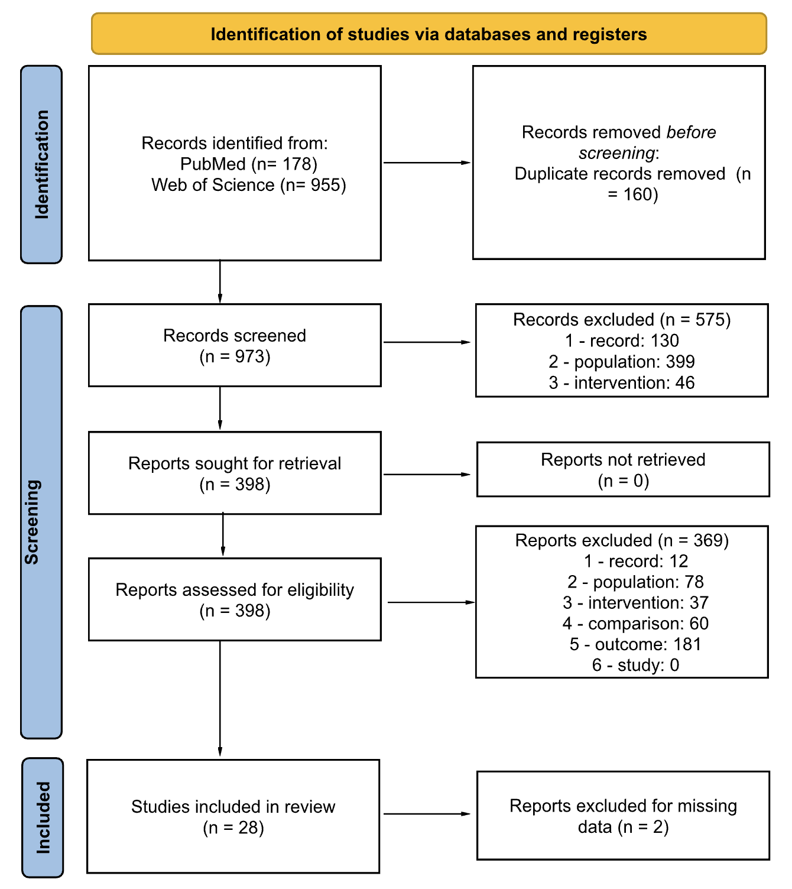
Figure 1 - Flowchart depicting the identification, screening, and inclusion process of studies in the replication attempt.
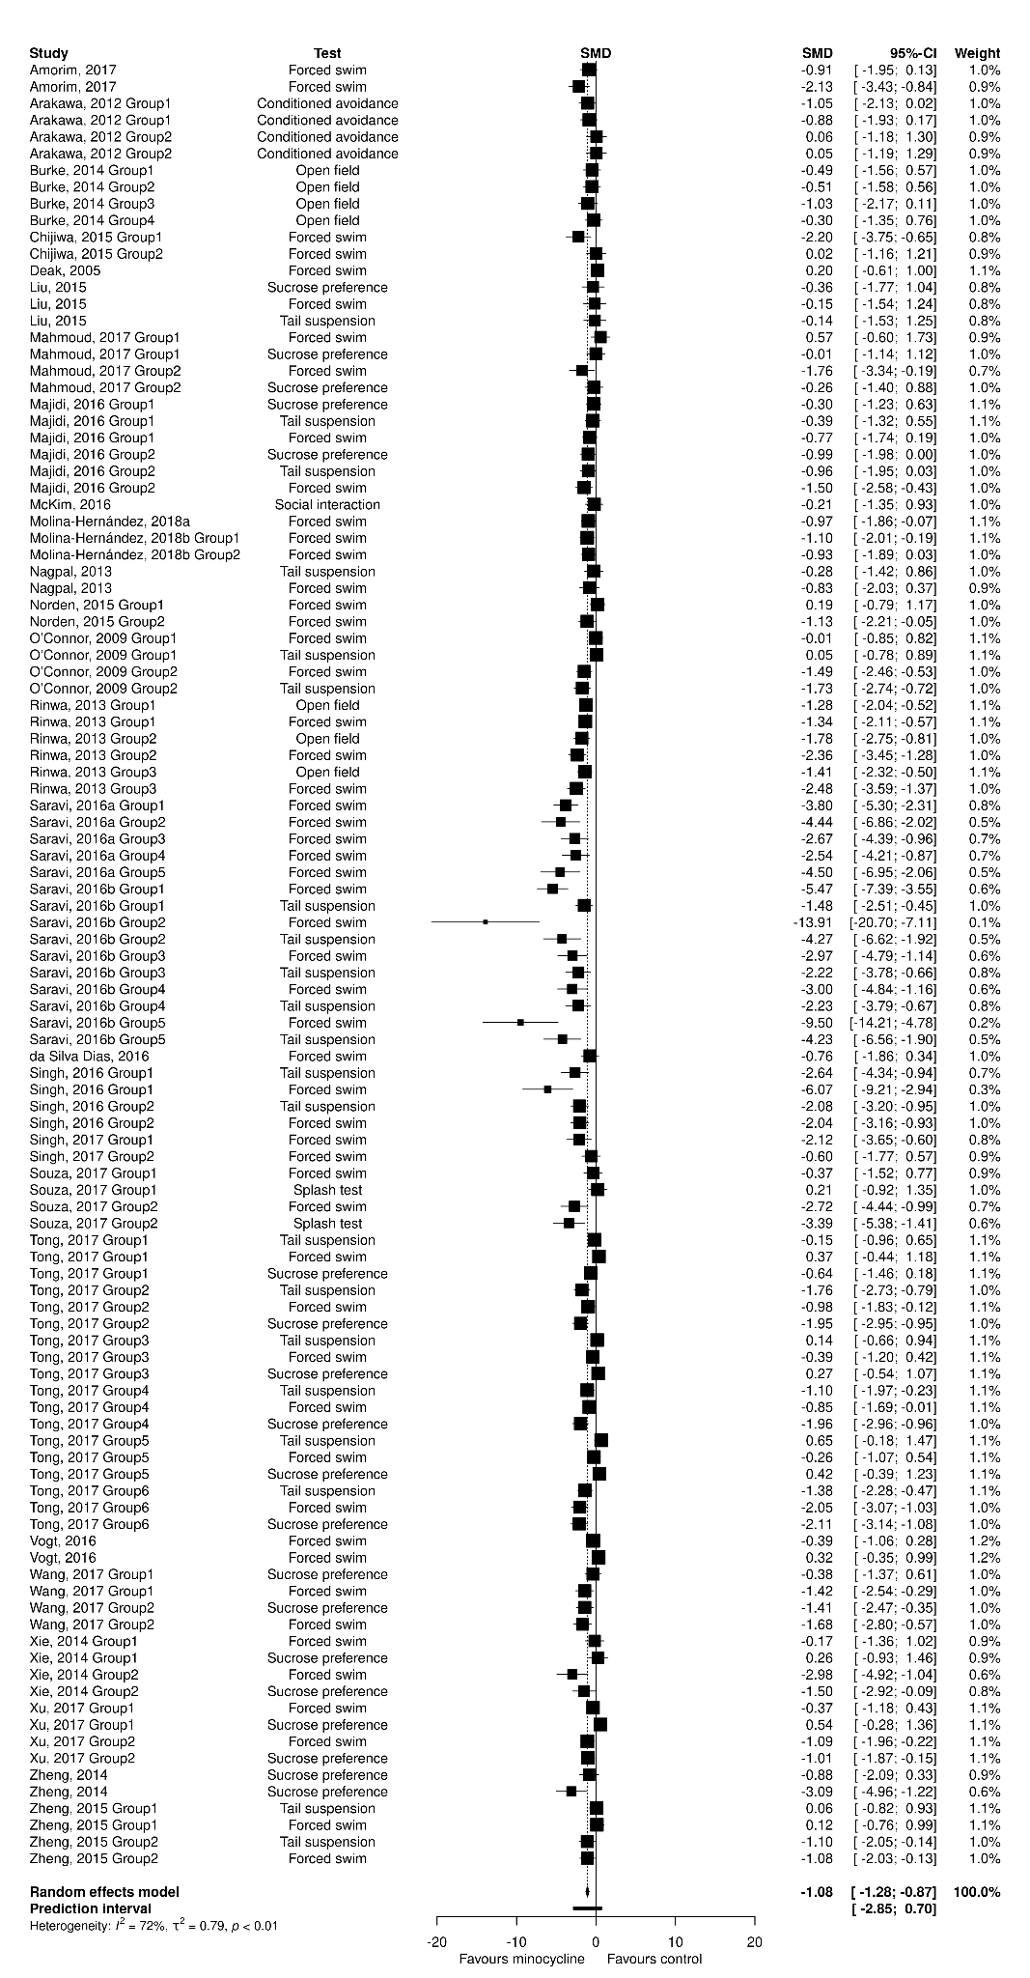
Figure 2 - Forest plot showing the overall standardized mean difference (SMD) for the effect of minocycline on depressive-like behaviors in rodent models. The plot includes individual outcomes from each study, categorized by test type (e.g., forced swim test, tail suspension test, sucrose preference test, etc.). The effect sizes (SMD) for each study are displayed as black squares, with horizontal lines representing the 95% confidence intervals (CI). The size of each square reflects the weight of the study in the meta-analysis.
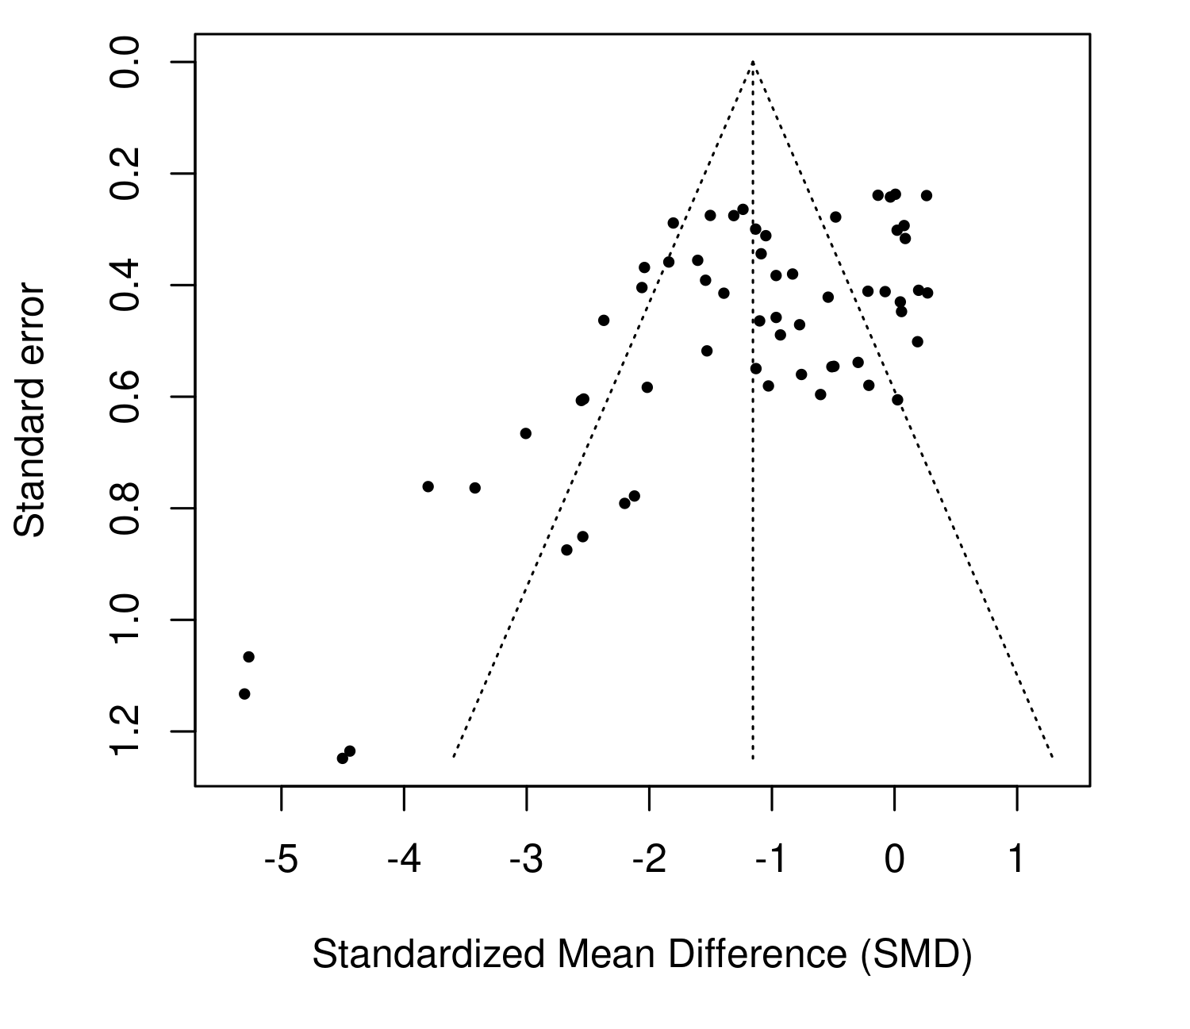
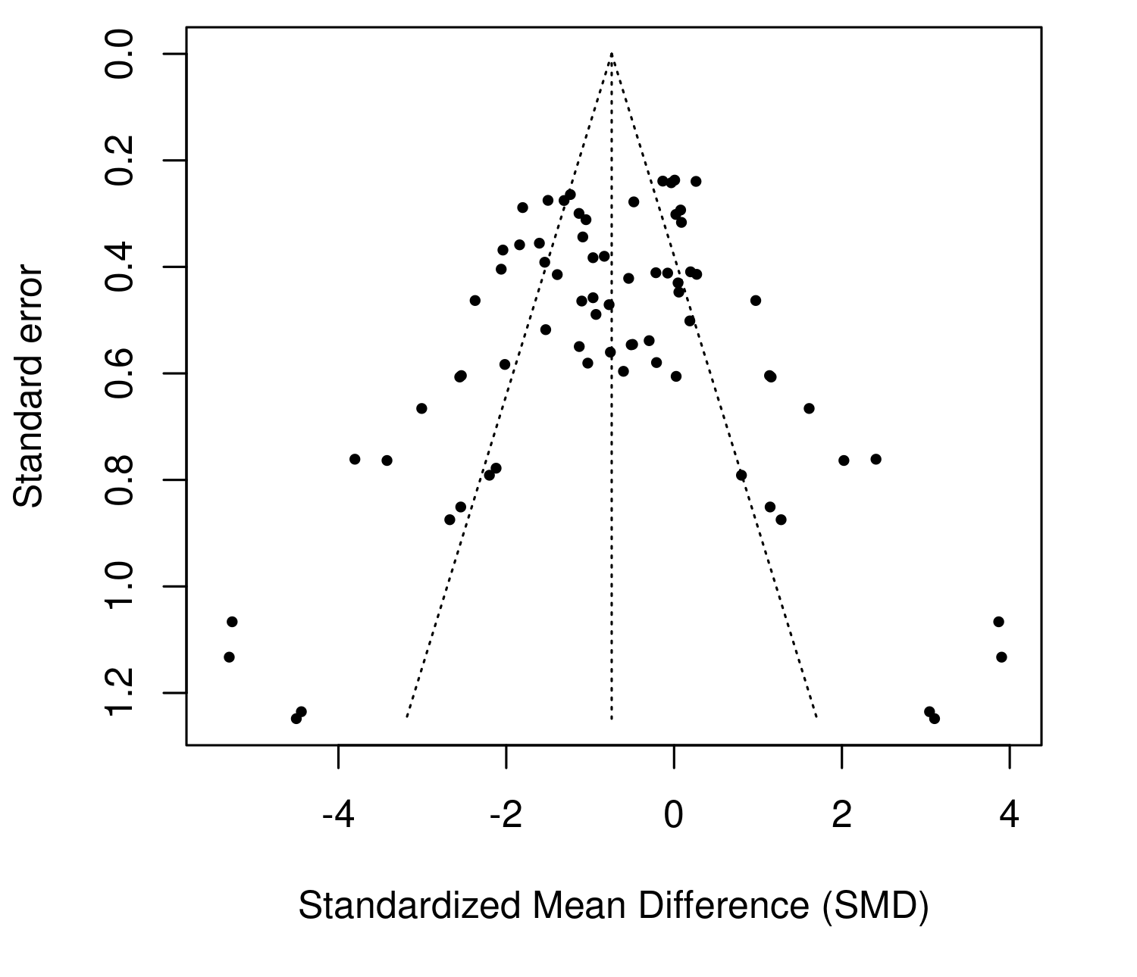
Figure 3 - Funnel plot of standardized mean differences.

Figure 4 - Funnel plot with trim-and-fill analysis showing the adjusted distribution of studies evaluating the effect of minocycline on depressive-like behaviors in rodent models.
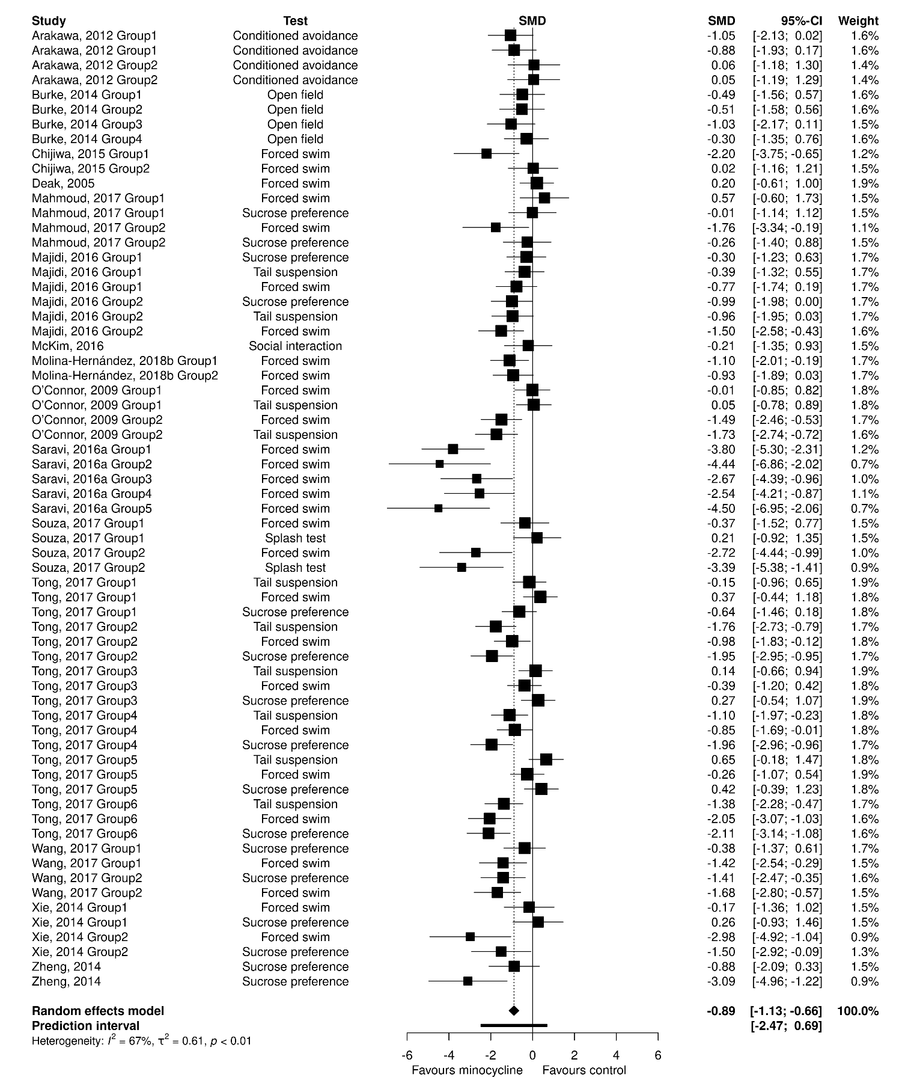
Figure 5 - Forest plot showing the overall standardized mean difference (SMD) for the effect of minocycline on depressive-like behaviors in rodent models after excluding studies with a high risk of bias. The plot includes individual outcomes from each study, categorized by test type (e.g., forced swim test, tail suspension test, sucrose preference test, etc.). The effect sizes (SMD) for each study are displayed as black squares, with horizontal lines representing the 95% confidence intervals (CI). The size of each square reflects the weight of the study in the meta-analysis.

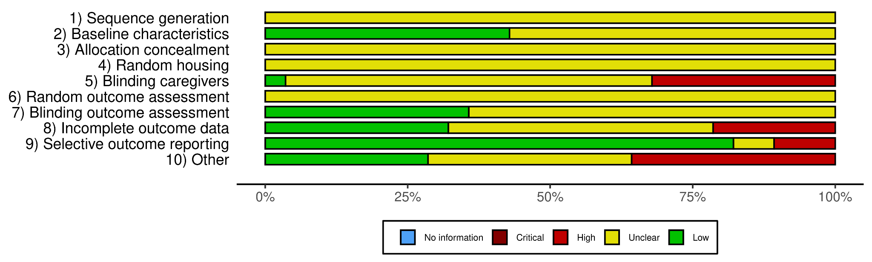
Figure 6 - General risk of bias assessment of included studies. The risk of bias assessment was performed by two independent investigators based on the SYRCLE’s risk of bias assessment tool.
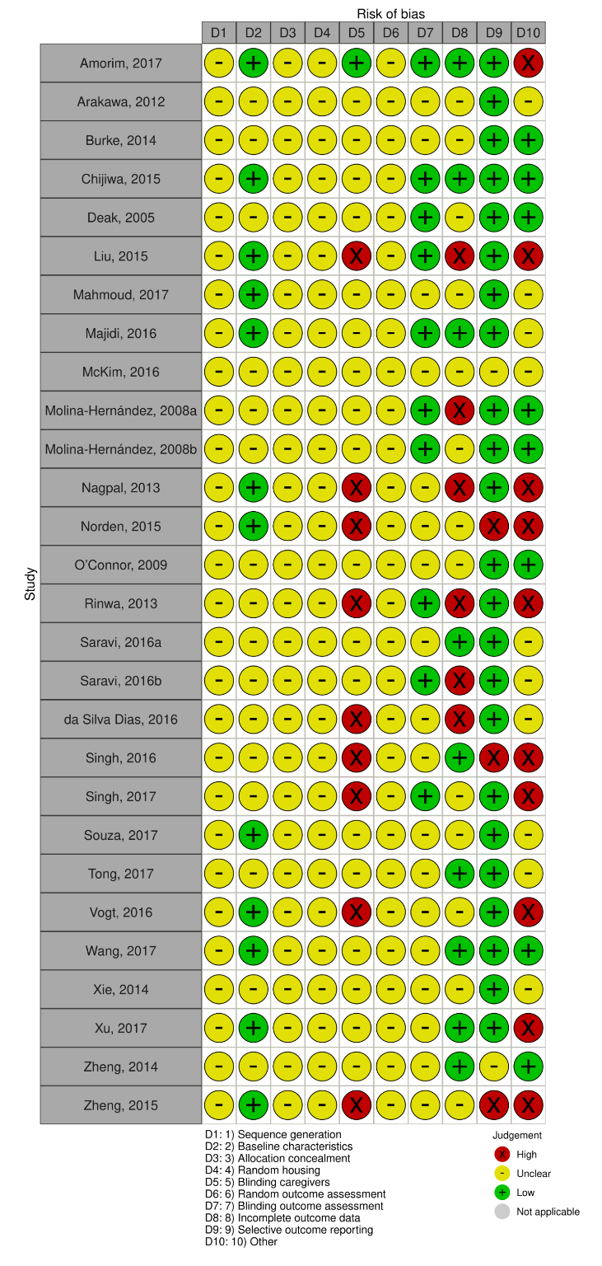
Figure 7 - Individualised scores for the risk of bias of each included study.

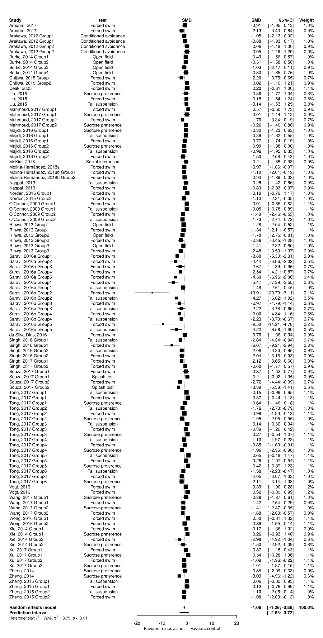

Figure 8 - Forest plot showing the overall standardized mean difference (SMD) for the effect of minocycline on depressive-like behaviors in rodent models, including the previously excluded study. The plot includes individual outcomes from each study, categorized by test type (e.g., forced swim test, tail suspension test, sucrose preference test, etc.). The effect sizes (SMD) for each study are displayed as black squares, with horizontal lines representing the 95% confidence intervals (CI). The size of each square reflects the weight of the study in the meta-analysis.

Table 1 - Qualitative description of included studies.
STUDY ID | ANIMAL MODEL | COMPARISON | OUTCOME
Amorim, 2017¹ | Streptozotocin | Vehicle x minocycline 80 mg/kg in Wistar Han rats injected with streptozotocin | Forced swim - immobility, latency to immobility
Arakawa, 2012² | None | Saline x minocycline 160 µg in naive Sprague-Dawley rats | Conditioned avoidance - failure numbers, latency to escape
Arakawa, 2012² | Learned helplessness | Saline x minocycline 20 or 160 µg in naive Sprague-Dawley rats subjected to the learned helplessness paradigm | Conditioned avoidance - failure numbers, latency to escape
Burke, 2014³ | None | Vehicle x minocycline 80 mg/kg in sham Sprague–Dawley rats | Open field - distance
Burke, 2014³ | Olfactory bulbectomy | Vehicle x minocycline 80 mg/kg in Sprague–Dawley rats subjected to olfactory bulbectomy | Open field - distance
Burke, 2014³ | None | Vehicle x minocycline 1 mg/mL in sham Sprague–Dawley rats | Open field - distance
Burke, 2014³ | Olfactory bulbectomy | Vehicle x minocycline 1 mg/mL in Sprague–Dawley rats subjected to olfactory bulbectomy | Open field - distance
Chijiwa, 2015⁴ | Social defeat stress | Vehicle x minocycline 50 mg/kg in Wistar rats subjected to social defeat stress | Forced swim - immobility
Chijiwa, 2015⁴ | Social defeat stress | Vehicle x minocycline 50 mg/kg in Wistar rats subjected to social defeat stress stress and injected with polyl:C | Forced swim - immobility
Deak, 2005⁵ | None | Vehicle x minocycline 20 or 40 mg/kg in Sprague-Dawley rats | Forced swim - immobility
Liu, 2015⁶ | Chronic unpredictable stress | Vehicle x minocycline 30 mg/kg in BALB/c mice subjected to chronic unpredictable stress | Forced swim - immobility;  Tail suspension - immobility; Sucrose preference - % preference
Mahmoud, 2017⁷ | None | PBS x minocycline 10 mg/kg in BALB/c mice | Forced swim - immobility; Sucrose preference - % preference
Mahmoud, 2017⁷ | Toxoplasma gondii infection | PBS x minocycline 10 mg/kg in BALB/c mice infected with T. gondii | Forced swim - immobility; Sucrose preference - % preference
Majidi, 2016⁸ | None | Saline x minocycline 30 mg/kg in NMRI mice | Forced swim - immobility; Tail suspension - immobility; Sucrose preference - % preference
Majidi, 2016⁸ | Lipopolysaccharide injection | Saline x minocycline 30 mg/kg in NMRI mice injected with lipopolysaccharide | Forced swim - immobility; Tail suspension - immobility; Sucrose preference - % preference
McKim, 2016⁹ | Social defeat stress | Vehicle x minocycline 90 mg/kg in C57BL/6 mice subjected to social defeat stress | Social interaction - time in interaction zone
Molina-Hernández, 2008a¹⁰ | None | Vehicle x minocycline 50, 60, or 80 mg/kg in Wistar rats | Forced swim - immobility
Molina-Hernández, 2008b¹¹ | None | Vehicle x minocycline 0.5, 1.0, or 1.5 µg in Wistar rats | Forced swim - immobility
Molina-Hernández, 2008¹¹ | None | Vehicle x minocycline 50 or 60 mg/kg in Wistar rats | Forced swim - immobility
Nagpal, 2013¹² | None | Saline x minocycline 100 mg/kg in Swiss albino mice | Forced swim - immobility; Tail suspension - immobility
Norden, 2015¹³ | None | Vehicle x minocycline 100 mg/kg in CD2F1 mice | Forced swim - immobility
Norden, 2015¹³ | Tumor growth | Vehicle x minocycline 100 mg/kg in CD2F1 mice subjected to tumor growth | Forced swim - immobility
O’Connor, 2009¹⁴ | None | Saline x minocycline 50 mg/kg in ICR mice | Forced swim - immobility; Tail suspension - immobility
O’Connor, 2009¹⁴ | Lipopolysaccharide injection | Saline x minocycline 50 mg/kg in ICR mice injected with lipopolysaccharide | Forced swim - immobility; Tail suspension - immobility
Rinwa, 2013¹⁵ | Olfactory bulbectomy | Vehicle x minocycline 25 or 50 mg/kg in Wistar rats subjected to olfactory bulbectomy | Forced swim - immobility; Open field - ambulations
Rinwa, 2013¹⁵ | Olfactory bulbectomy | Vehicle x minocycline 25 mg/kg in Wistar rats subjected to olfactory bulbectomy and treated with quercetin (low dose) | Forced swim - immobility; Open field - ambulations
Rinwa, 2013¹⁵ | Olfactory bulbectomy | Vehicle x minocycline 25 mg/kg in Wistar rats subjected to olfactory bulbectomy and treated with quercetin (medium dose) | Forced swim - immobility; Open field - ambulations
Saravi, 2016a¹⁶ | Testicular torsion | Untreated x minocycline 40, 80, or 160 mg/kg in Wistar rats subjected to testicular torsion | Forced swim - immobility
Saravi, 2016b¹⁷ | Malathion exposure | Saline x minocycline 40, 80, or 160 mg/kg in NMRi mice exposed to malathion | Forced swim - immobility; Tail suspension - immobility
da Silva Dias, 2016¹⁸ | Streptozotocin | Vehicle x minocycline 60 mg/kg in Wistar rats injected with streptozotocin | Forced swim - immobility
Singh, 2016¹⁹ | Kindling | Saline x minocycline 40 mg/kg in Swiss mice subjected to kindling | Forced swim - immobility; Tail suspension - immobility
Singh, 2016¹⁹ | Kindling | Valproate x minocycline 10, 20, or 40 mg/kg in Swiss mice subjected to kindling and treated with valproate | Forced swim - immobility; Tail suspension - immobility
Singh, 2017²⁰ | Chronic restraint stress | Control x minocycline 100 mg/kg in albino LACA mice subjected to chronic restraint stress | Forced swim - immobility
Singh, 2017²⁰ | Chronic restraint stress | Ramipril x minocycline 100 mg/kg in albino LACA mice subjected to chronic restraint stress and treated with ramipril | Forced swim - immobility
Souza, 2017²¹ | None | Saline x minocycline 50 mg/kg in C57BL/6 mice | Forced swim - immobility; Splash test - grooming time
Souza, 2017²¹ | Streptozotocin | Saline x minocycline 50 mg/kg in C57BL/6 mice injected with streptozotocin | Forced swim - immobility; Splash test - grooming time
Tong, 2017²² | None | Water x minocycline 40 mg/kg in control ICR mice of the chronic unpredictable stress group | Forced swim - immobility; Tail suspension - immobility; Sucrose preference - % preference
Tong, 2017²² | Chronic unpredictable stress | Water x minocycline 40 mg/kg in ICR mice subjected to chronic unpredictable stress | Forced swim - immobility; Tail suspension - immobility ; Sucrose preference - % preference
Tong, 2017²² | None | Water x minocycline 40 mg/kg in control ICR mice of the chronic restraint stress group | Forced swim - immobility; Tail suspension - immobility; Sucrose preference - % preference
Tong, 2017²² | Chronic restraint stress | Water x minocycline 40 mg/kg in ICR mice subjected to chronic restraint stress | Forced swim - immobility; Tail suspension - immobility; Sucrose preference - % preference
Tong, 2017²² | None | Water x minocycline 40 mg/kg in control ICR mice of the chronic social defeat stress group | Forced swim - immobility; Tail suspension - immobility; Sucrose preference - % preference
Tong, 2017²² | Chronic social defeat stress | Water x minocycline 40 mg/kg in ICR mice subjected to chronic social defeat stress | Forced swim - immobility; Tail suspension - immobility; Sucrose preference - % preference
Vogt, 2016²³ | None | Saline x minocycline 20 or 40 mg/kg in C57BL/6 mice | Forced swim - immobility, latency to immobility
Wang, 2017²⁴ | None | Saline x minocycline 50 mg/kg in Sprague-Dawley rats | Forced swim - immobility; Sucrose preference - % preference
Wang, 2017²⁴ | Early-life social isolation | Saline x minocycline 50 mg/kg in Sprague-Dawley rats subjected to early-life social isolation | Forced swim - immobility; Sucrose preference - % preference
Xie, 2014²⁵ | None | Water x minocycline 120 mg/kg in Wistar rats | Forced swim - immobility; Sucrose preference - % preference
Xie, 2014²⁵ | Status epilepticus | Water x minocycline 120 mg/kg in Wistar rats subjected to status epilepticus | Forced swim - immobility; Sucrose preference - % of total fluids
Xu, 2017²⁶ | None | Vehicle x minocycline 40 mg/kg in sham Sprague-Dawley rats | Forced swim - immobility; Sucrose preference - % preference
Xu, 2017²⁶ | Spare nerve injury | Vehicle x minocycline 40 mg/kg in Sprague-Dawley rats subjected to spare nerve injury | Forced swim - immobility; Sucrose preference - % preference
Zheng, 2014²⁷ | Lipopolysaccharide injection | Saline x minocycline 30 mg/kg in Wistar rats injected with lipopolysaccharide | Sucrose preference - % preference, sucrose water intake
Zheng, 2015²⁸ | None | PBS x minocycline 50 mg/kg in C57BL/6 mice | Forced swim - immobility; Tail suspension - immobility
Zheng, 2015²⁸ | Interferon-alpha injection | PBS x minocycline 50 mg/kg in C57BL/6 mice injected with interferon-alpha | Forced swim - immobility; Tail suspension - immobility

References for qualitative table and risk of bias figures:

1. Amorim, D. et al. Minocycline reduces mechanical allodynia and depressive-like behaviour in type-1 diabetes mellitus in the rat. Behav. Brain Res. 327, 1–10 (2017).
2. Arakawa, S. et al. Minocycline produced antidepressant-like effects on the learned helplessness rats with alterations in levels of monoamine in the amygdala and no changes in BDNF levels in the hippocampus at baseline. Pharmacol. Biochem. Behav. 100, 601–606 (2012).
3. Burke, N. N., Kerr, D. M., Moriarty, O., Finn, D. P. & Roche, M. Minocycline modulates neuropathic pain behaviour and cortical M1–M2 microglial gene expression in a rat model of depression. Brain. Behav. Immun. 42, 147–156 (2014).
4. Chijiwa, T., Oka, T., Lkhagvasuren, B., Yoshihara, K. & Sudo, N. Prior chronic stress induces persistent polyI:C-induced allodynia and depressive-like behavior in rats: Possible involvement of glucocorticoids and microglia. Physiol. Behav. 147, 264–273 (2015).
5. Deak, T. et al. Behavioral responses during the forced swim test are not affected by anti-inflammatory agents or acute illness induced by lipopolysaccharide. Behav. Brain Res. 160, 125–134 (2005).
6. Liu, Y.-N. et al. TNFα mediates stress-induced depression by upregulating indoleamine 2,3-dioxygenase in a mouse model of unpredictable chronic mild stress. Eur. Cytokine Netw. 26, 15–25 (2015).
7. Mahmoud, M. E., Fereig, R. & Nishikawa, Y. Involvement of Host Defense Mechanisms against Toxoplasma gondii Infection in Anhedonic and Despair-Like Behaviors in Mice. Infect. Immun. 85, 10.1128/iai.00007-17 (2017).
8. Majidi, J., Kosari-Nasab, M. & Salari, A.-A. Developmental minocycline treatment reverses the effects of neonatal immune activation on anxiety- and depression-like behaviors, hippocampal inflammation, and HPA axis activity in adult mice. Brain Res. Bull. 120, 1–13 (2016).
9. McKim, D. B. et al. Neuroinflammatory Dynamics Underlie Memory Impairments after Repeated Social Defeat. J. Neurosci. 36, 2590–2604 (2016).
10. Molina-Hernández, M., Tellez-Alcántara, N. P., Pérez-García, J., Olivera-Lopez, J. I. & Jaramillo-Jaimes, M. T. Antidepressant-like actions of minocycline combined with several glutamate antagonists. Prog. Neuropsychopharmacol. Biol. Psychiatry 32, 380–386 (2008).
11. Molina-Hernández, M., Téllez-Alcántara, N. P., Pérez-García, J., Olivera-Lopez, J. I. & Jaramillo-Jaimes, M. T. Desipramine or glutamate antagonists synergized the antidepressant-like actions of intra-nucleus accumbens infusions of minocycline in male Wistar rats. Prog. Neuropsychopharmacol. Biol. Psychiatry 32, 1660–1666 (2008).
12. Nagpal, K., Singh, S. K. & Mishra, D. Evaluation of safety and efficacy of brain targeted chitosan nanoparticles of minocycline. Int. J. Biol. Macromol. 59, 20–28 (2013).
13. Norden, D. M. et al. Tumor growth increases neuroinflammation, fatigue and depressive-like behavior prior to alterations in muscle function. Brain. Behav. Immun. 43, 76–85 (2015).
14. O’Connor, J. C. et al. Lipopolysaccharide-induced depressive-like behavior is mediated by indoleamine 2,3-dioxygenase activation in mice. Mol. Psychiatry 14, 511–522 (2009).
15. Rinwa, P. & Kumar, A. Quercetin suppress microglial neuroinflammatory response and induce antidepressent-like effect in olfactory bulbectomized rats. Neuroscience 255, 86–98 (2013).
16. Saravi, S. S. S., Mousavi, S. E., Saravi, S. S. S. & Dehpour, A. R. Minocycline Attenuates Depressive-Like Behaviour Induced by Rat Model of Testicular Torsion: Involvement of Nitric Oxide Pathway. Basic Clin. Pharmacol. Toxicol. 118, 249–258 (2016).
17. Saeedi Saravi, S. S. et al. On the effect of minocycline on the depressive-like behavior of mice repeatedly exposed to malathion: interaction between nitric oxide and cholinergic system. Metab. Brain Dis. 31, 549–561 (2016).
18. da Silva Dias, I. C. et al. Indoleamine-2,3-Dioxygenase/Kynurenine Pathway as a Potential Pharmacological Target to Treat Depression Associated with Diabetes. Mol. Neurobiol. 53, 6997–7009 (2016).
19. Singh, T. & Goel, R. K. Adjuvant indoleamine 2,3-dioxygenase enzyme inhibition for comprehensive management of epilepsy and comorbid depression. Eur. J. Pharmacol. 784, 111–120 (2016).
20. Singh, B., Mourya, A., Sah, S. P. & Kumar, A. Protective effect of losartan and ramipril against stress induced insulin resistance and related complications: Anti-inflammatory mechanisms. Eur. J. Pharmacol. 801, 54–61 (2017).
21. Souza, L. C. et al. Intracerebroventricular Administration of Streptozotocin as an Experimental Approach to Depression: Evidence for the Involvement of Proinflammatory Cytokines and Indoleamine-2,3-Dioxygenase. Neurotox. Res. 31, 464–477 (2017).
22. Tong, L. et al. Microglia Loss Contributes to the Development of Major Depression Induced by Different Types of Chronic Stresses. Neurochem. Res. 42, 2698–2711 (2017).
23. Vogt, M. A. et al. Minocycline does not evoke anxiolytic and antidepressant-like effects in C57BL/6 mice. Behav. Brain Res. 301, 96–101 (2016).
24. Wang, H.-T. et al. Early-Life Social Isolation-Induced Depressive-Like Behavior in Rats Results in Microglial Activation and Neuronal Histone Methylation that Are Mitigated by Minocycline. Neurotox. Res. 31, 505–520 (2017).
25. Xie, W. et al. Activation of brain indoleamine 2,3-dioxygenase contributes to epilepsy-associated depressive-like behavior in rats with chronic temporal lobe epilepsy. J. Neuroinflammation 11, 41 (2014).
26. Xu, N. et al. Spared Nerve Injury Increases the Expression of Microglia M1 Markers in the Prefrontal Cortex of Rats and Provokes Depression-Like Behaviors. Front. Neurosci. 11, (2017).
27. Zheng, X. et al. Peripheral immunomodulation with ginsenoside Rg1 ameliorates neuroinflammation-induced behavioral deficits in rats. Neuroscience 256, 210–222 (2014).
28. Zheng, L.-S., Kaneko, N. & Sawamoto, K. Minocycline treatment ameliorates interferon-alpha- induced neurogenic defects and depression-like behaviors in mice. Front. Cell. Neurosci. 9, (2015).

